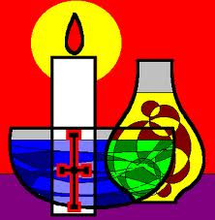
A Note about the
Sacrament of the Sick

From ancient times there is evidence of the anointing of the sick in our Church’s tradition. We profess that this anointing is one of the seven sacraments of the New Testament. Our Lord’s desire is to accompany and strengthen those who are seriously or chronically ill.
Since Vatican Council II, the Church emphasizes that this anointing of the sick is not a sacrament for those only who are at the point of death (Extreme Unction) but for those whose health is compromised by serious illness or advancing age.
The Church states in its Constitution on the Liturgy that “great care and concern should be taken to see that those of the faithful whose health is seriously impaired by sickness or advancing age receive the sacrament.”
With this understanding and appreciation of the anointing of the sick, our parishioners are encouraged to request this sacrament for themselves or immediate family members as soon as serious illness or advancing age begins to impair health. It is not necessary to delay the Sacrament of Anointing until it becomes an extreme situation at the moment of death.
Normally as a parish practice, we anoint regularly our parishioners who are home-bound and in various nursing homes. Both Fr. Pius and Fr. John anoint parishioners upon request before their hospital stays as well as in unplanned emergency situations. PLEASE NOTE: Due to the pandamic and current protocols, there may be some changes in administering this Sacrament.
May we pray for our brothers and sisters whose health is impaired. May we offer them the hope of the Sacrament of the Sick, our prayers and our companionship as a faith community.

